|  |  |  |
| --- | --- | --- |
|  | JSS MAHAVIDYAPEETHA  JSS ACADEMY OF TECHNICAL EDUCATION  Affiliated to Visvesvaraya Technological University, Belagavi, Karnataka, INDIA  Approved by All India Council for Technical Education, New Delhi  UG programs accredited by NBA: ECE, CSE, ISE, CIVIL, MECHANICAL, IEM, E & IE | vtu logo.png |

**Department of Computer Science and Engineering**

Academic year 2021-22 Odd semester

ACTIVITY

TITLE: **Display temperature on 7 segment using LM35 temperature sensor and Arudino board**

Name of the student with USN:

1. SHREYAS P (1JS20CS157)
2. SHUBHANKAR SHARMA (1JS20CS158)
3. SHASHWATH B N (1JS20CS148)
4. SANSKRITI SINGH (1JS20CS144)

|  |  |  |  |
| --- | --- | --- | --- |
| Branch and Section | | : COMPUTER SCIENCE AND ENGINEERING | |
| Semester | | : 4th SEMESTER | |
| Name of the Faculty | | : | |
|  |  |  |  |
|  | Marks secured: |  |  |
|  |  |  |  |
|  | In figures: |  | In words: |
|  |  |  |  |
| Signature of Faculty(s): | |  |  |
|  | |  |  |

Remarks if any:

**CONTENT**

**CIRCUIT DIAGRAM**

**Display temperature on 7 segment using LM35 temperature sensor and Arudino board**

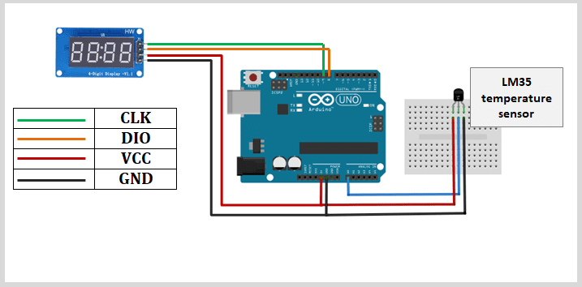

**ABSTRACT**

**CONTENT**

* **INTRODUCTION**
* **ABSTRACT**
* **DESCRIPTION OF PROJECT**
* **WORKING PRINCIPLE & CIRCUIT CONNECTIONS**
* **APPLICATION**
* **CONCLUSION**
* **REFERENCE**

**INTRODUCTION**

**Embedded Systems:**

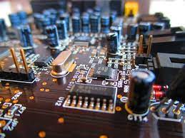

An embedded system is a combination of computer hardware and software designed for a specific function. Embedded systems may also function within a larger system. The systems can be programmable or have a fixed functionality. Industrial machines, consumer electronics, agricultural and processing industry devices, automobiles, medical equipment, cameras, digital watches, household appliances, airplanes, vending machines and toys, as well as mobile devices, are possible locations for an embedded system.

The processor may be a microprocessor or microcontroller. Microcontrollers are simply microprocessors with peripheral interfaces and integrated memory included. Microprocessors use separate integrated circuits for memory and peripherals instead of including them on the chip. Both can be used, but microprocessors typically require more support circuitry than microcontrollers because there is less integrated into the microprocessor.

The term system on a chip ([SoC](https://internetofthingsagenda.techtarget.com/definition/system-on-a-chip-SoC)) is often used. SoCs include multiple processors and interfaces on a single chip. They are often used for high-volume embedded systems. Some example SoC types are the application-specific integrated circuit ([ASIC](https://www.techtarget.com/whatis/definition/ASIC-application-specific-integrated-circuit)) and the field-programmable gate array (FPGA).

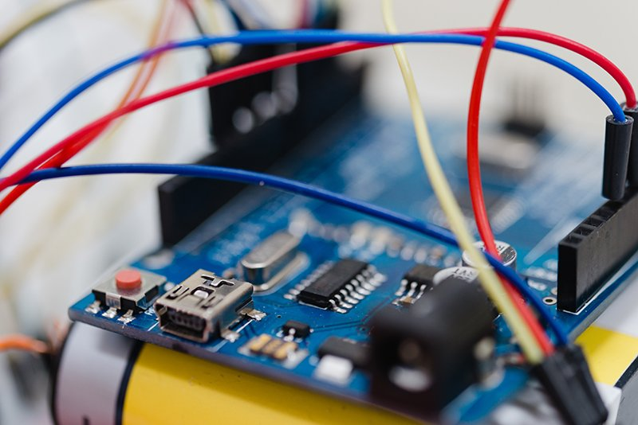

### Characteristics of embedded systems

The main characteristic of embedded systems is that they are task-specific.

Additionally, embedded systems can include the following characteristics:

* typically, consist of hardware, software and firmware;
* can be embedded in a larger system to perform a specific function, as they are built for specialized tasks within the system, not various tasks;
* can be either microprocessor-based or microcontroller-based -- both are integrated circuits that give the system compute power;
* are often used for sensing and real-time computing in internet of things ([IoT](https://internetofthingsagenda.techtarget.com/definition/Internet-of-Things-IoT)) devices, which are devices that are internet-connected and do not require a user to operate;
* can vary in complexity and in function, which affects the type of software, firmware and hardware they use; and
* are often required to perform their function under a time constraint to keep the larger system functioning properly.

**Structure of embedded systems**

Embedded systems vary in complexity but, generally, consist of three main elements:

* **Hardware.** The hardware of embedded systems is based around microprocessors and microcontrollers. Microprocessors are very similar to microcontrollers and, typically, refer to a CPU (central processing unit) that is integrated with other basic computing components such as memory chips and digital signal processors ([DSPs](https://www.techtarget.com/whatis/definition/digital-signal-processing-DSP)). Microcontrollers have those components built into one chip.
* **Software and firmware.** Software for embedded systems can vary in complexity. However, industrial-grade microcontrollers and embedded IoT systems usually run very simple software that requires little memory.
* **Real-time operating system.** These are not always included in embedded systems, especially smaller-scale systems. RTOSes define how the system works by supervising the software and setting rules during program execution.

In terms of hardware, a basic embedded system would consist of the following elements:

* **Sensors** convert physical sense data into an electrical signal.
* **Analog-to-digital (A-D) converters** change an analog electrical signal into a digital one.
* **Processors** process digital signals and store them in memory.
* **Digital-to-analog (D-A) converters** change the digital data from the processor into analog data.
* **Actuators** compare actual output to memory-stored output and choose the correct one.

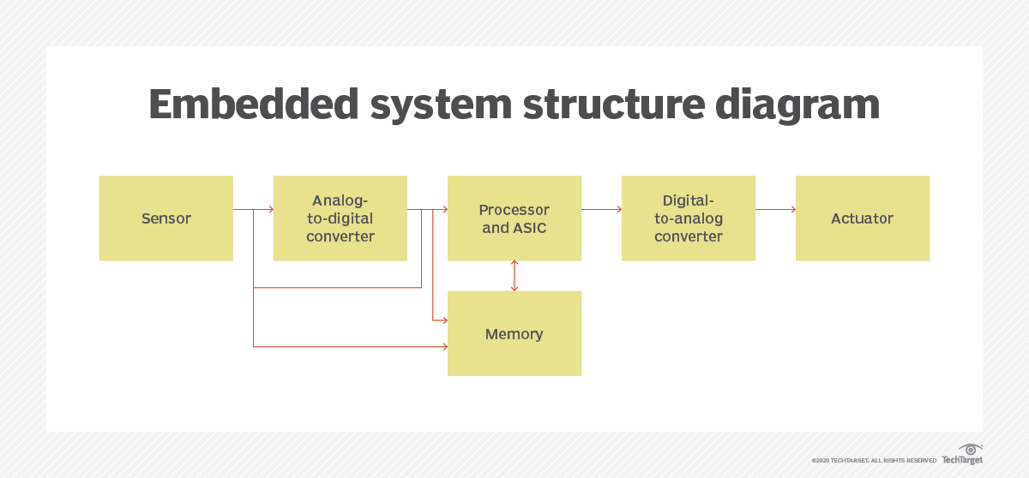

**PURPOSE OF EMBEDDED SYSTEMS:**

As mentioned in the previous section, embedded systems are used in various domains like consumer electronics, home automation, telecommunications, automotive industry, healthcare, control & instrumentation, retail and banking applications, etc. Each embedded system is designed to serve the purpose of any one or a combination of the following tasks:

1.**Data Collection, Storage, Representation**

• Data is collection of facts, such as values or measurements. It can be numbers, words, measurements, observations, or even just description of things.

Purpose of embedded system design is data collection. It performs acquisition of data from the external world.

• Data collection is usually done for storage, analysis, manipulation, and transmission.

The Data can be analog or digital. Embedded systems with analog data capturing techniques collect data directly in the form of analog signal; whereas embedded systems with digital data collection mechanism convert the analog signal to corresponding digital signal using analog to digital (A/D) converters. • If the data is digital, it can be directly captured by digital embedded system. A digital camera is a typical example of an embedded system with data collection, storage, and representation of data. Images are captured and captured image may be stored within the memory of the camera. The captured image can also be presented to the user through a graphic LCD (Liquid Crystal Display) unit.

2. **Data Communication**

• Embedded data communication systems are deployed in applications ranging from simple home networking systems to complex satellite communication systems. o Network hubs, routers, switches are examples of dedicated data transmission embedded systems.

• Data transmission is in the form of wire medium or wireless medium. Initially wired medium is used by embedded systems; and as technology changes, wireless medium becomes de-facto standard in embedded systems.

o USB, TCP/ IP are examples of wired communication; and Bluetooth, ZigBee and Wi-Fi are examples for wireless communication.

• Data can be transmitted by analog means or by digital means.

3. **Data (Signal) Processing**

• Embedded systems with signal processing functionalities are employed in applications demanding signal processing like speech coding, audio-video codec, transmission applications, etc.

o A digital hearing aid is a typical example of an embedded system employing data processing

4.**Monitoring**

• Almost all embedded products coming under the medical domain are with monitoring functions.

o Patient heart beat is monitored by Electro cardiogram (ECG) machine. 6 In the current occasions, the use of embedded systems is broad. However, the software which is customized into the microcontroller is equipped for understanding just a constrained scope of issues. Embedded system based activities can perform multiple tasks and are additionally fit for interfacing with different systems, network, and gadgets.

Few examples of the purpose of embedded systems in real-world are as follows: Detecting rash driving in traffic- The fundamental goal of this is to structure an expressway speed-checker gadget that distinguishes rash driving on thruways and cautions the traffic authorities if the speed checker finds any vehicle damaging the set speed constrains on roadways.

Purpose of an embedded system in street light control- The primary aim is to recognize the movement of vehicles on interstates and to turn on road lights in front of it, and afterward to turn off the road lights as the vehicle go past the road lights to save energy.

Embedded System for home automation system-The fundamental purpose of embedded systems in home automation is to plan a home robotization framework with the Android application based remote control. Remote activity is performed by Android OS based advanced cell or Tablet and so on., upon a Graphical User Interface based touch screen activity. So as to accomplish this, Android application goes about as a transmitter that sends on/off orders to the beneficiary wherein loads are associated.

Embedded System for Industrial Temperature Control- The primary purpose of the embedded system of this mechanical temperature controller is to control the temperature of any gadget in any modern application as per its need. An LCD show is utilized to show the temperature in the scope of – 55°C to +125°C. The core of the circuit is the microcontroller which is from 8051 families and controls every one of its capacities.

**Uses Of Embedded System:**

Embedded systems are used in a wide range of technologies across an array of industries. Some examples include:

* **Automobiles.** Modern cars commonly consist of many computers (sometimes as many as 100), or embedded systems, designed to perform different tasks within the vehicle. Some of these systems perform basic utility functions and others provide entertainment or user-facing functions. Some embedded systems in consumer vehicles include cruise control, backup sensors, suspension control, navigation systems and airbag systems.
* **Mobile phones.** These consist of many embedded systems, including GUI software and hardware, operating systems (OSes), cameras, microphones, and USB (Universal Serial Bus) I/O (input/output) modules.
* **Industrial machines.** They can contain embedded systems, like sensors, and can be embedded systems themselves. Industrial machines often have embedded automation systems that perform specific monitoring and control functions.
* **Medical equipment.** These may contain embedded systems like sensors and control mechanisms. Medical equipment, such as industrial machines, also must be very user-friendly so that human health isn't jeopardized by preventable machine mistakes. This means they'll often include a more complex OS and GUI designed for an appropriate UI.

**PROGRAM CODE**

#include <TM1637Display.h>

const int CLK = 3; //Set the CLK pin connection to the display

const int DIO = 2; //Set the DIO pin connection to the display

const uint8_t blank[] = {0x00, 0x00, 0x00,0x00};

const int tempPin = A0;

// Create degree Celsius symbol:

const uint8_t celsius[] = {

SEG_A | SEG_B | SEG_F | SEG_G, // Circle

SEG_A | SEG_D | SEG_E | SEG_F // C

};

// Create degree Fahrenheit symbol:

const uint8_t fahrenheit[]

= {

SEG_A | SEG_B | SEG_F | SEG_G, // Circle

SEG_A | SEG_E | SEG_F | SEG_G // F

};

TM1637Display display(CLK, DIO); //set up the 4-Digit Display.

void setup()

{

display.setBrightness(0x0a); //set the diplay to maximum brightness

display.setSegments(blank);//clear display

}

void loop()

{

int value = analogRead(tempPin); // read the value from sensor

float millivolts = (value / 1024.0) * 5000;

int t = millivolts / 10; // temperature in degrees celcius

int f = (t * 9)/5 + 32; // convert celcius to fahrenheit

// Show the temperature on the TM1637 display:

display.showNumberDec(t, false, 2, 0);

display.setSegments(celsius, 2, 2);

delay(2000);

display.showNumberDec(f, false, 2, 0);

display.setSegments(fahrenheit, 2, 2);

delay(2000);

}

**APPLICATION**

**Conclusion**

**Reference**

* <https://youtu.be/exFMW2AqZG0>
* <https://miliohm.com/how-to-use-lm35-temperature-sensor-with-arduino/>
* <https://create.arduino.cc/projecthub/s126171/temperature-monitor-using-4-digit-7-segment-display-965f53>
* <https://www.instructables.com/Simple-Seven-Segment-Temperature-Display-Using-Ard/>
* https://microcontrollerslab.com/lm35-temperature-sensor-with-7-segment-display-pic-microcontroller/